SignSpeak: Real-Time Arabic Sign Language Translation Using Machine Learning and Computer Vision
Aaron Rababaah, American University of Kuwait, Kuwait (arababaah@auk,edu.kw)
Farah Al-Bashiti, American University of Kuwait, Kuwait (S00065821@auk,edu.kw)
Zahraa Khalaf, American University of Kuwait, Kuwait (S00058128@auk,edu.kw)
Eman Aldossari, American University of Kuwait, Kuwait (S00053895@auk,edu.kw)
Noor Alzubaidi, American University of Kuwait, Kuwait (S00056262@auk,edu.kw)

ABSTRACT
People who rely on sign language face difficulties when communicating with others who do not understand it. This problem appears clearly in Arabic speaking communities where tools for Arabic Sign Language are limited. This paper presents SignSpeak, a system that translates hand gestures into text and speech in real time.
The system uses a camera to capture hand movements. It detects hand landmarks and sends the data to a trained model. The model predicts the gesture and converts it into Arabic text. The system also produces speech output so others can understand the message. In addition, the system includes features such as recording and a learning mode.
The results show good accuracy in controlled conditions. The system responds quickly and supports smooth interaction. This work focuses on improving communication and providing a simple solution that works on common devices, tailored for Arabic-speaking communities, particularly in Kuwait and the MENA region.
Keywords: Arabic Sign Language, Gesture Recognition, Machine Learning, Computer Vision, Accessibility.
- INTRODUCTION
Communication is the heart of everyday life. People use it to share ideas, ask for help, and interact with others. For individuals who use Arabic sign language, communication becomes difficult when the other person does not understand it, which creates challenges in places such as schools, hospitals, and public services. This communication gap is evident in regions such as Kuwait, where accessible assistive technologies for Arabic sign language are limited.
Although several sign language translation systems exist, most are designed for American Sign Language (ASL) where Arabic users can’t really benefit from due to their use of Arabic sign language. Additionally, many systems rely on expensive hardware such as sensors or gloves, limiting their accessibility and practical use.
To address these challenges, this paper presents SignSpeak, a system that translates Arabic Sign Language into text and speech in real-time. The system utilizes machine learning and computer vision to recognize hand gestures using a standard camera, making it cost-effective and accessible to everyone which aligns with our goal of providing a simple tool that helps users communicate in real situations.
The basic contributions of this work are:
- A real-time ArSL gesture recognition system
- A low-cost solution with camera-based input
- Integration of text-to-speech for communication
- Inclusion of educational and recording features.

- LITERATURE REVIEW
Enabling natural communication between humans and robots, gesture recognition has developed into a major area of human-computer interaction. Particularly hand gestures, capturing and deciphering human movements is used to carry out certain activities or transmit information. The use of machine learning, especially convolutional neural networks (CNNs), has been very important in making gesture recognition systems more accurate and faster (Krizhevsky et al., 2012).
Deep learning models have been used in a number of studies to recognize sign language. CNN-based methods have shown great results in extracting visual characteristics and detecting patterns in gesture data (Krizhevsky et al., 2012). Furthermore, transfer learning approaches have been applied to tailor pre-trained models to particular sign language datasets, increasing accuracy and cutting down on training time (Pan & Yang, 2010).
Research on Arabic Sign Language in comparison with ASL is still somewhat scarce (Alazemi et al., 2024; Alfarrarjeh et al., 2018). Some researchers have concentrated on identifying individual Arabic alphabet movements using datasets such as ArASL (Alazemi et al., 2024; Alrahayfeh & Faezipour, 2015). Although these methods have great accuracy, they are often limited to static gestures and do not provide real-time communication or ongoing translation capabilities.
Existing systems like HandSpeak (Handspeak, 2026) and SignAll (SignAll, 2025) illustrate both advances and limits in this area. HandSpeak gives a pictorial lexicon for learning sign language but lacks real-time interactive capability (Handspeak, 2026). On the other hand, SignAll provides sophisticated gesture recognition but demands specialist hardware and controlled settings, hence limiting its availability for daily use (SignAll, 2025).
Sensitivity of gesture recognition systems to environmental factors, such as illumination, background noise, and changes in hand shape and motion, presents a significant difficulty. Moreover, restricts the performance and generalizability of current models the dearth of large and diverse datasets for Arabic Sign Language. These constraints point to the need for a practical, real-time, and accessible technology customized especially for Arabic Sign Language users. The planned SignSpeak system seeks to close these gaps by using computer vision, machine learning, and user-centered design all together.
- THE PROCESS OF THE SYSTEM
This section provides a detailed explanation of the SignSpeak system, highlighting its primary features and the ways in which users interact with it.
The system translates Arabic Sign Language gestures into meaningful outputs in real time. Leveraging advanced machine vision technology, it captures hand gestures and converts them into both text and speech.
The overall process model of the SignSpeak system is shown in Figure 1 together with the order of operations from gesture capture to output production. The procedure starts with filming hand movements with a camera, then moves on to hand landmark identification, feature extraction, gesture categorization, and at last producing text and speech outputs.
Functionality 1: Converting Hand Gestures into Text and Speech
This feature is the primary building block of the system. Real-time capture of the user's hand movements in front of a camera takes place. MediaPipe is used to capture hand landmarks, including the positions of the fingers and the coordinates of the joints. The extracted features are fed into a trained neural network model, which then categorizes the gesture into a predetermined class. The system then connects the gesture to its equivalent Arabic word or phrase once it has been recognized. Using a text-to-speech converter, the output is simultaneously transformed into speech and shown as text on the screen.

Functionality 2: Real-time recording of translated sessions
The technology lets users document their translated communications. Recognized gestures and their related outputs are kept in a structured manner during operation. This tool lets consumers look back at earlier contacts and use them for documentation or learning objectives.
Functionality 3: Educational Model
The system has an educational mode that teaches users Arabic Sign Language. This tool presents instructional material, including gesture demonstrations, so that consumers may imitate and repeat signs. Based on gesture identification, the technology offers feedback to improve the learning process.
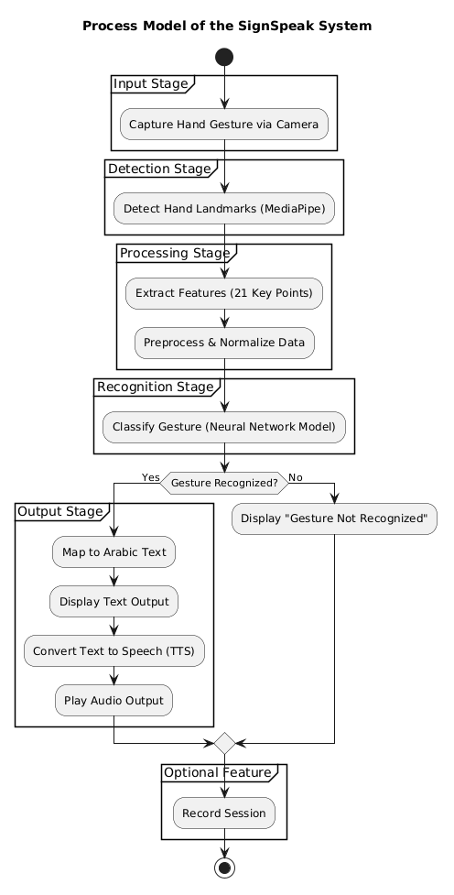
Figure 1: Process Model of the SignSpeak System
System Design Diagrams
The system design is supported by several diagrams, including activity diagram (figure 2), use case diagram (figure 3), which show how system components interact with user input. These diagrams show in detail how users interact with the system and how operations flow within the SignSpeak system.
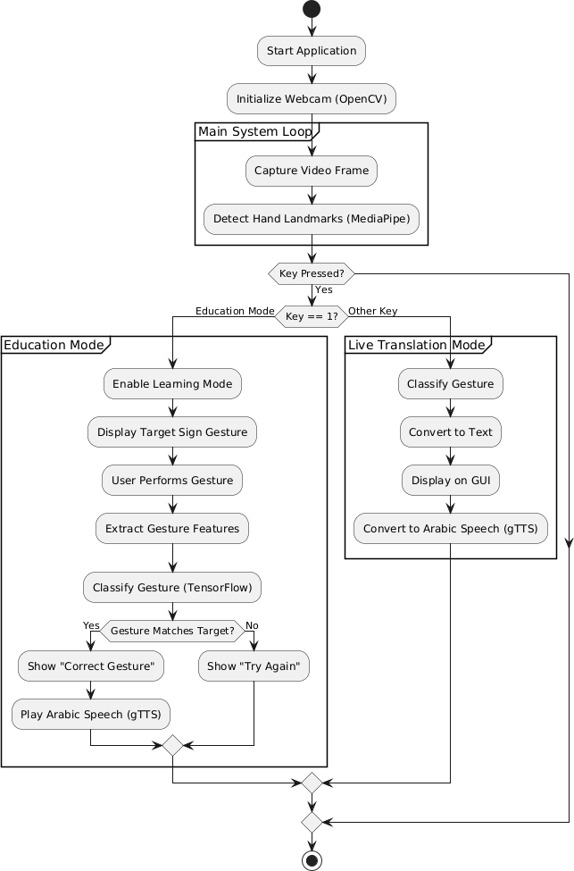
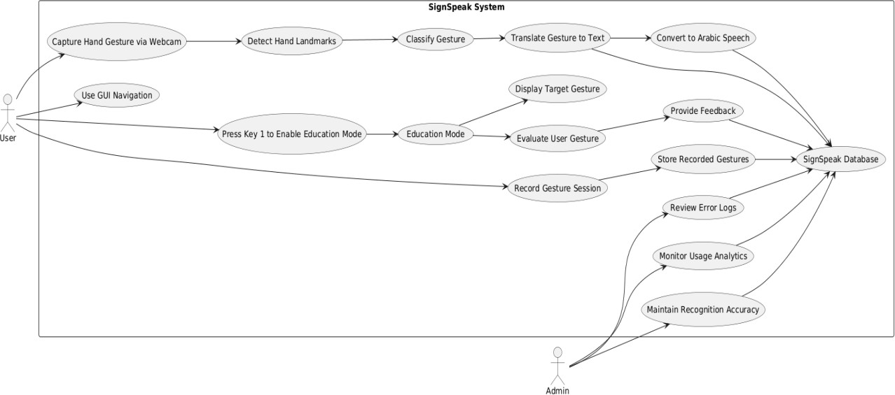
Figure 2: Activity Diagram of the SignSpeak System
Figure 3: Use Case Diagram of the SignSpeak System
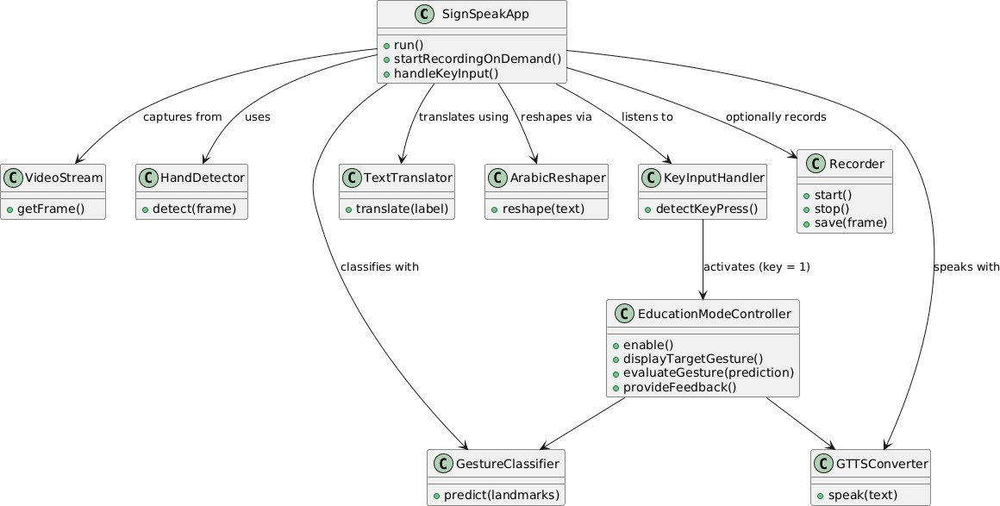
Figure 4: Class Diagram of the SignSpeak System
- EXPERIENTIAL WORK
The SignSpeak system was developed using Python as the main programming language, integrating OpenCV for real-time video capture from the camera and MediaPipe for hand detection and tracking, where the system extracts 21 key points from the hand (including finger positions and joints), which are used as an input feature for the model. Gesture classification was handled by a TensorFlow model trained on Arabic sign language datasets. During execution, the model predicts gestures and returns the corresponding label. To ensure accessibility, the system was optimized for standard laptop hardware, requiring no external sensors.
Evaluation showed that SignSpeak performs effectively in controlled environments, providing real-time text and speech translation with minimal latency. User testing confirmed that the intuitive interface allowed for seamless interaction, while the educational mode successfully assisted users in practicing gestures.
However, to ensure the system’s robustness across all operating conditions, a deeper analysis was conducted into potential failures points. While general feedback was positive, figure 4 presents a fishbone diagram that isolates the root causes of “low gesture recognition accuracy” observed during challenging scenarios, such as poor lighting or complex backgrounds.
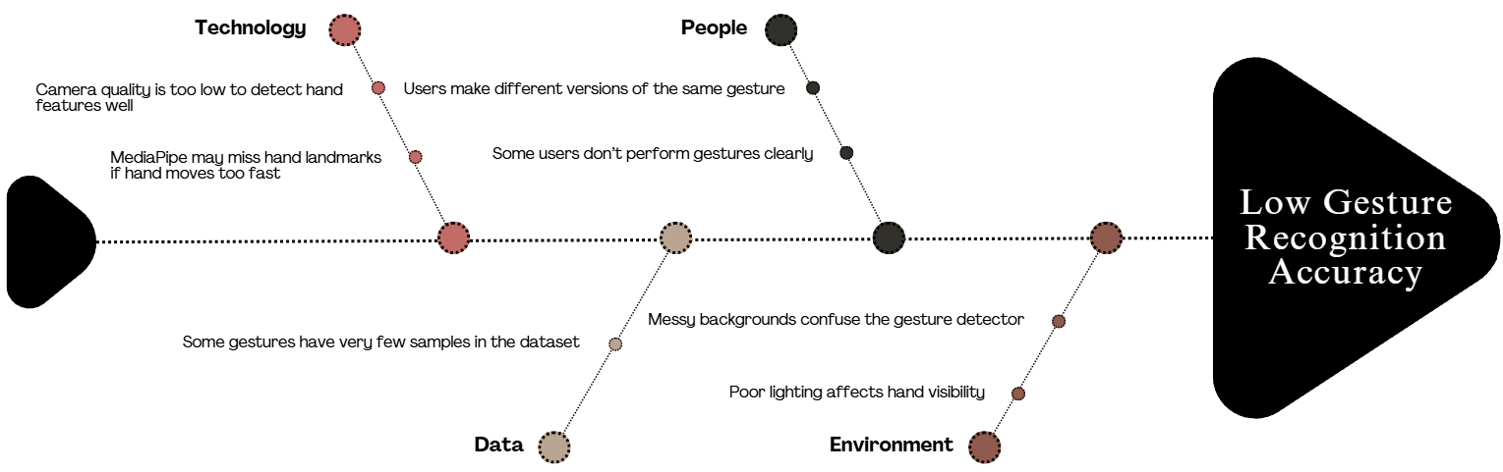
Figure 4: Fishbone Diagram of Software Failure Causes
- RISK ANALYSIS
Risk analysis is an essential component in the development of the SignSpeak system, as it helps identify potential issues and implement mitigation strategies.
One major risk is gesture misrecognition, where the system incorrectly interprets a gesture due to similarities between hand shapes. This issue can be addressed by improving the dataset and training the model with more diverse samples.
Another risk involves environmental conditions such as poor lighting or cluttered backgrounds, which can affect hand detection accuracy. This can be mitigated by optimizing the model and providing user guidelines for proper usage.
System crashes and performance issues also represent potential risks. These can be minimized through proper error handling and system testing.
Security risks related to stored recordings must also be considered. Implementing data protection measures ensures user privacy and system reliability.
Rank | Risk | Description | Category | Root  Cause | Potential  Response | Probability | Impact
R1 | Gesture misrecognition | Incorrect gesture is translated into wrong  text/speech | Performance Risk | Inaccurate gesture-to-text mapping | Improve gesture dataset and re-train the model | High | High
R2 | System crash | Software stops responding during use | System Risk | Unhandled exceptions or bugs | Perform extensive debugging and exception handling | Medium | High
R3 | Background/en vironment interference | Gesture not recognized due to poor lighting or clutter | Environme ntal Risk | Noisy backgroun d or insufficient lighting | Use environment-  invariant tracking or instruct user guidelines | Medium | Medium
R4 | Unauthorized access to recordings | Saved conversation logs accessed by unauthorized  users | Security Risk | Lack of proper access control | Implement authentication and encryption of logs | High | Medium
R5 | Ambiguity between similar gestures | System confuses two similar hand shapes | Usability Risk | Lack of gesture distinctiven ess in  dataset | Refine gesture set and train for better classification | Medium | Medium
R6 | Hardware limitation (camera) | Poor camera quality leads to inaccurate detection | Hardware Risk | Low-resolution or low-FPS camera | Recommend minimum hardware specs or optimize for  low input | Low | Medium
Table 1: Risk Analysis of the SignSpeak System
- SURVEY
To better understand user needs and evaluate the potential impact of the system, a survey was conducted with 83 participants.
The survey results indicated strong interest in a sign language translation application, particularly one that operates in real time. Participants expressed the need for accessible tools that improve communication between sign language users and non-users.
The results also highlighted the importance of additional features such as learning modules and recording capabilities. These findings influenced the design and functionality of the SignSpeak system.
Overall, the survey confirmed the relevance and necessity of the proposed system in addressing communication challenges.
Survey Questions | Results
Do you know how to communicate with others using Arabic Sign Language? | Yes: 7.2%  No: 89.2%  Somewhat: 3.6%
Do you know a person who is deaf/hard of hearing/struggling with speech? | Yes: 31.3%  No: 68.7%
If there was a software used for translating sign language into speech and text, would you use it? | Yes: 84.3%  No: 15.7%
Would you be interested in learning Arabic Sign Language through the software’s AI for free? | Yes: 84.3%  No: 15.7%
Which feature matters most to you in a sign language translation software? | Real-time Translation: 44%  Learning Mode: 48%  Recording & Playback: 8%
Do you think a tool like SignSpeak can improve inclusion in society? | Yes: 88%  No: 0%  Maybe: 12%
Table 2: Survey Results of the SignSpeak Systems
- CONCLUSION
A real-time Arabic Sign Language recognition and translation system that seamlessly combines computer vision, machine learning, and assistive technology is successfully delivered by the SignSpeak project. Using a webcam, the system can identify hand gestures, extract useful features, classify signs accurately, and display the results in Arabic text, speech output, recording, and an interactive learning mode.
Usability, dependability, and privacy were prioritized throughout the development process. With a privately deployed machine learning model, the system runs mostly offline, guaranteeing low latency and safeguarding user data. Without sacrificing system stability, optional features like text-to-speech and session recording improve accessibility and user engagement. Furthermore, by incorporating user feedback and reinforcement mechanisms, the system can gather important information for future model enhancement.
Thorough testing has also proved that SignSpeak works efficiently in a real-world setting and functions in a stable manner when used for an extended period. Although certain factors, such as lighting, complexity, and speed of movement, can impact the recognition performance, the system still works properly. Moreover, the successful implementation of the learning feature further adds to the system’s capabilities, which not only translate but also acts as a source for communications and a means for learning. In summary, SignSpeak achieves its purpose and has a good foundation for any possible improvements, such as sign vocabulary, resistance of errors, and portability of the system on any mobile device.
- RUNNING THE SOFTWARE:
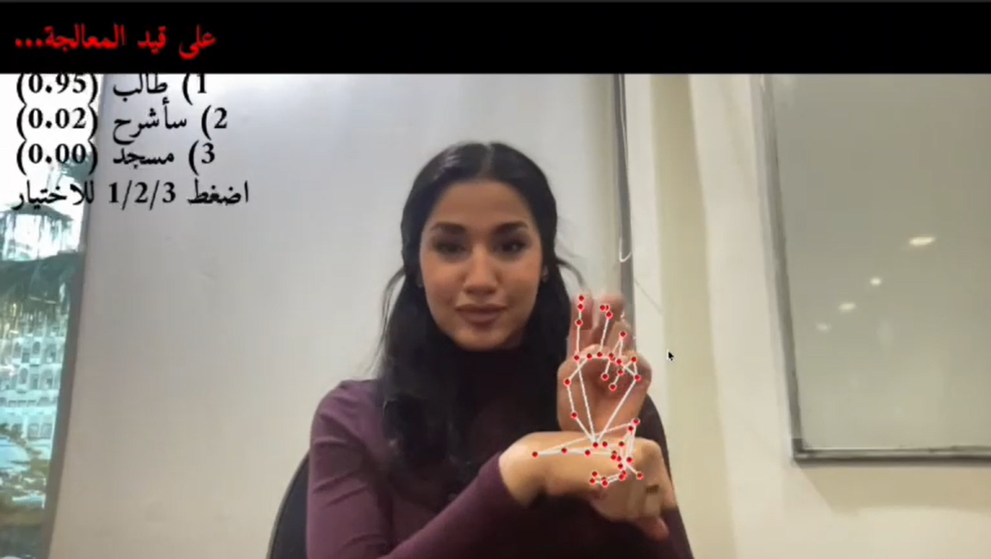

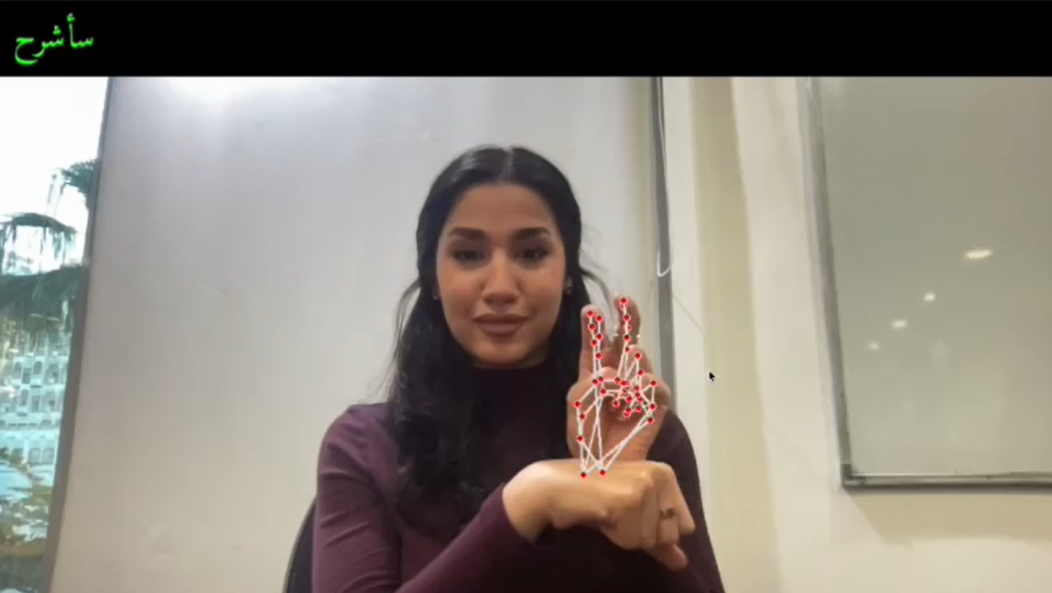
Figure 5: user gesturing سأشرح
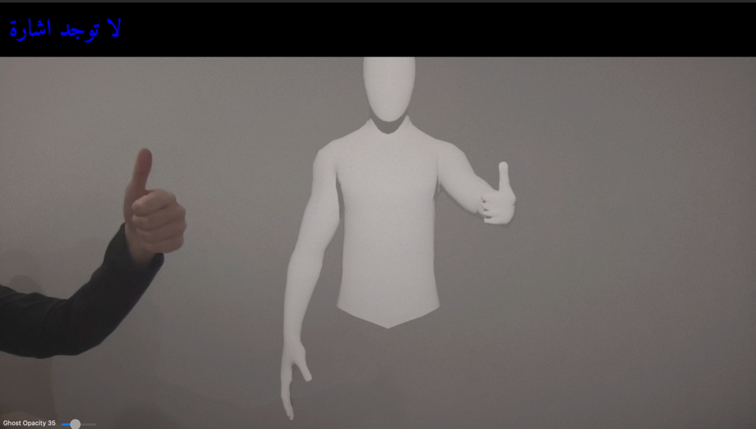
Figure 6: user utilizing the learning mode

REFERENCES
Alazemi, A., Khandoker, A., & Jalab, H. A. (2024). Arabic sign language recognition using deep learning: A comparative study of CNN and transformer models (arXiv:2410.00681). arXiv. https://arxiv.org/abs/2410.00681
Alfarrarjeh, M., Aksoy, S., Shah, M., & Al-Hmouz, A. (2018). ArSL2018: A large-scale video-based Arabic sign language dataset. In Proceedings of the IEEE Winter Conference on Applications of Computer Vision (WACV) (pp. 147–156). IEEE.
Alrahayfeh, A. K., & Faezipour, M. A. (2015). RGB image-based Arabic alphabets sign language recognition. In 2015 Long Island Systems, Applications and Technology Conference (LISAT) (pp. 1–6). IEEE.
Handspeak. (2026). About. Handspeak ASL Dictionary. https://www.handspeak.com/word/6/
Krizhevsky, A., Sutskever, I., & Hinton, G. E. (2012). ImageNet classification with deep convolutional neural networks. Communications of the ACM, 60(6), 84–90. https://proceedings.neurips.cc/paper_files/paper/2012/file/c399862d3b9d6b76c8436e924a68c45b-Paper.pdf
Pan, S. J., & Yang, Q. (2010). A survey on transfer learning. IEEE Transactions on Knowledge and Data Engineering, 22(10). https://doi.org/10.1109/TKDE.2009.191
SignAll. (2025). SignAll sign language translation app. https://signall.world/

